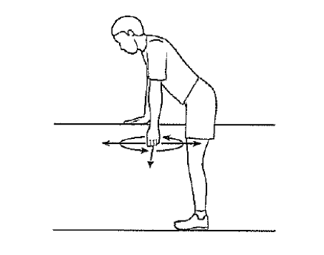

***Pendulum exercises***

Remove your sling, bend over at the waist and let the arm hang down. Using your body to initiate the movement, swing the arm gently forward and backward and in a circular motion.

***Supine passive forward elevation***

Lie on your back. Hold the affected arm at the elbow with the opposite hand. Assisting with the opposite arm, lift the operated arm upward, as if to bring the arm overhead. Slowly lower the arm back to the bed.

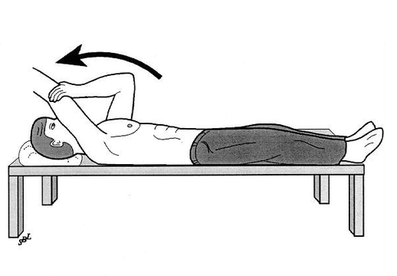

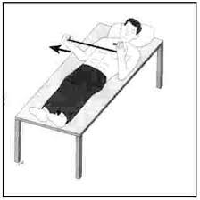

NEUTRAL 30 DEGREES AS MUCH AS POSSIBLE

***Supine external rotation***

Lie on your back. Keep the elbow of the operated arm against your side with the elbow bent 90 degrees. Using a cane or a long stick in the opposite hand, push against the hand of the operated arm so that the operated arm rotates outward. Hold for 10 seconds, relax and repeat. The amount of allowed external rotation will be specified after surgery.

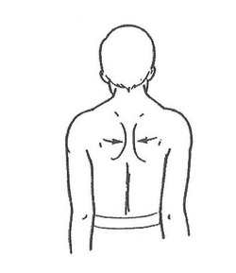

***Shoulder blade pinches***

While standing, pinch shoulder blades backward and together.